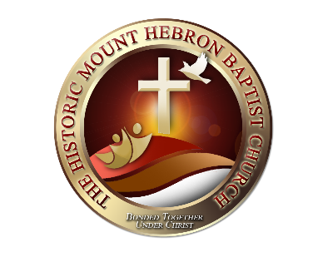
NEW MEMBERS QUIZ
REV. DR. BERYL M. WHIPPLE, PASTOR
On the church website, click on the link, take the quiz, and email your answers to the Deacons at Deaconministry@mounthebron.org. Once your quiz has been graded, you will receive further instructions.
Directions: Answer the questions by circling the correct answer.
- In what year was Mt. Hebron founded and organized?
- January 1, 1918
- February 14, 1867
- September 26, 1927
- December 25, 1950

- What is doctrine?
- What we made up.
- What we are trying to find.
- What we believe.
- What we are writing.

- As Baptists, what we believe is called
- The Articles of Faith
- The Ten Commandments
- The Covenant
- The Holy Bible

- What are the two ordinances of the church we observe?
- Baptism and communion
- Pray and fasting
- Scripture reading and worship
- Fasting and singing

- How can you become a member of the church?
- Baptism
- Christian experience
- Letter of transfer
- A, B, and C

- Church membership offers opportunities for
- Fellowship
- Christian growth and development
- Christian training and service
- All of the above

- As members of the church, God wants us to be
- Helpful, Hopeful, and Honorable
- Intelligent, Insightful, and Integral
- Active, Aware, Willing to Learn, and Authentic.
- Excited, Energetic, and Enthusiastic

- Where in the Bible can you find our guidelines for discipleship?
- The Ten Commandments
- The Great Commission
- The Resurrection
- The Seven Last Words

- The essentials of discipleship are
- Outreach, Bible Study, fellowship, and worship
- Pray, scripture reading, and meditation
- Fasting, service, and witnesses
- All of the above
- None of the above

- Discipleship means
- To grow from spiritual infancy to spiritual maturity in Christ through our actions, life, and words
- How we present ourselves to the world
- To reproduce the process to someone else
- All of the above
- None of the above

Bonus Question
The motto of our church is
- “The church that guides people to Christ”
- “We are a family of believers”
- “Great is thy faithfulness”
- “Bonded together under Christ”
- None of the above

Name: ________________________________________________

